How To Setup A Linux Server As IPTABLES FIREWALL

Linux distributions are used in every domain, from embedded systems to supercomputers. Use of Linux distributions in home and enterprise desktops has been growing. They have also gained popularity with the capability to support various kinds of applications for business needs. Here we will explain how to use Linux for setting up some basic business requirements like FTP, HTTP, MAIL, DNS, Router, Proxy etc which are very costly services provided by technologies like Microsoft.

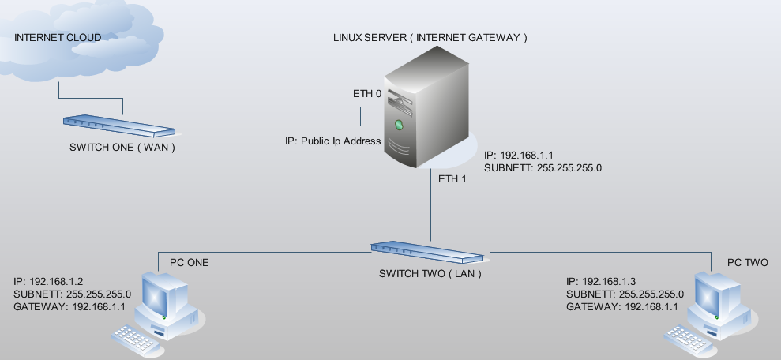

Linux Server:
eth0 ( External Interface )
eth1 ( Internal Netwok Interface) ( 192.168.1.X series )
Step 1. Enable ip nat in linux kernel.
"echo '1' > /proc/sys/net/ipv4/ip_forward"
Step 2. Assign IP address to eth0 and eth1
-------------------------------------------------------
/etc/sysconfig/network-scripts/ifcfg-eth0
DEVICE=eth0
ONBOOT=yes
IPADDR=xxx.xxx.xxx.xxx
NETMASK=255.255.255.xxx
GATEWAY=xxx.xxx.xxx.xxx
TYPE=Ethernet
BOOTPROTO=static
HWADDR=00:11:5B:F6:E2:5D
-------------------------------------------------------
-------------------------------------------------------
/etc/sysconfig/network-scripts/ifcfg-eth1
DEVICE=eth1
ONBOOT=yes
IPADDR=192.168.1.1
NETMASK=255.255.255.0
TYPE=Ethernet
BOOTPROTO=static
HWADDR=00:29:5X:FG:32:8S
-------------------------------------------------------
"service network restart"
Step 3. Set iptable commands.
"iptables -F"
"iptables --table nat --append POSTROUTING --out-interface eth0 -j MASQUERADE"
"iptables --append FORWARD --in-interface eth1 -j ACCEPT"
Step 4. Add the above entries to /etc/rc.local file.
/etc/rc.local
/sbin/iptables -F 2>/dev/null
/sbin/iptables --table nat --append POSTROUTING --out-interface eth0 -j MASQUERADE 2>/dev/null
/sbin/iptables --append FORWARD --in-interface eth1 -j ACCEPT 2>/dev/null

